Relecloud – Business Overview and Acquisition Analysis
Prepared for Fabrikam Executive Review

1. Company Overview
Basic Information. Relecloud, Ltd. is a cloud-first software company headquartered in Dublin, Ireland, founded in 2016. The leadership team includes CEO Mira O’Donnell, CFO Liam Byrne, CTO Priya Natarajan, and COO Javier Ruiz. Relecloud is privately held with a mix of venture and employee ownership. The company has ~1,150 employees across 7 offices (Dublin, London, Berlin, Toronto, Austin, Singapore, Sydney).
Business Model. Revenue is generated primarily through subscription software (SaaS ~72%), cloud infrastructure services (~18%), and consulting/managed services (~10%). Pricing is tiered (Essential, Growth, Enterprise), with per-seat and usage-based components.
Vision, Mission, and Strategy. Vision: empower digital businesses to deliver secure, scalable, and data-driven experiences. Mission: simplify multi-cloud operations for mid-market and enterprise customers. Strategy: expand platform capabilities via AI-driven observability, security automation, and industry-specific solution packs; grow via EMEA and North American enterprise accounts and selective channel partnerships.
Products and Services. Core products include Relecloud Control (multi-cloud orchestration), Relecloud Secure (cloud security posture management), Relecloud Insight (observability and analytics), and Relecloud Edge (device and edge workload management). Services include implementation consulting, managed operations, and premium support SLAs.

2. Market Position and Industry Analysis
Target Market: Lower-to-mid enterprise (500–5,000 employees) and regulated SMBs across fintech, retail, healthcare, and SaaS providers.
Market Share & Positioning: In EMEA mid-enterprise cloud management, Relecloud holds an estimated 3.4% share, competing with established platforms and niche tools. Differentiation centers on rapid deployment, security automation, and total cost of ownership (TCO) advantages.
Industry Trends: Continued cloud migration, AI-assisted operations (AIOps), zero-trust security, and data sovereignty rules. Opportunities include AI-driven remediation and sector packs; threats include hyperscaler native tooling, price compression, and evolving data regulations.
Competitors: Major—Datadog, Wiz, HashiCorp (Terraform Cloud), and ServiceNow (Cloud Ops). Niche—Lacework, Snyk Cloud, and several EU-focused security startups. Relecloud differentiates via integrated orchestration + security, strong mid-market economics, and turnkey compliance templates.

3. Financial Performance
Year | Revenue (USD mm) | COGS (USD mm) | Operating Expenses (USD mm) | EBITDA (USD mm) | Net Income (USD mm)
2021.0 | 118.4 | 36.1 | 62.5 | 19.8 | 8.6
2022.0 | 152.7 | 47.6 | 79.2 | 25.9 | 11.2
2023.0 | 201.9 | 64.2 | 99.0 | 38.7 | 18.1
2024.0 | 262.5 | 83.7 | 121.4 | 57.4 | 28.3
2025.0 | 324.8 | 104.5 | 144.2 | 76.1 | 38.9

Revenue streams: SaaS (Essential 28%, Growth 26%, Enterprise 18%), Cloud Services 18%, Consulting 10%. Gross margin improved from 69% (2021) to 68% (2025) (mix shift to cloud services slightly offsets SaaS margin gains). Operating margin expanded from 16.7% to 23.4%. Liquidity remains strong with cash and equivalents at $112mm (Oct 2025), debt $85mm (net debt $-27mm).
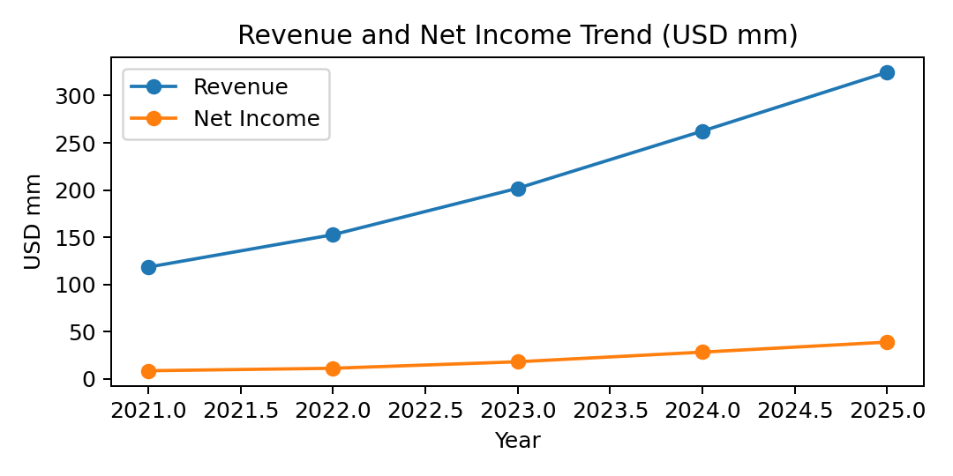

4. Customer and Sales Insights
Metric | Value
Total Customers | 2,480
Enterprise Accounts | 410 (17%)
SMB/Commercial | 2,070 (83%)
Top 10 Customer % of Revenue | 31%
Renewal Rate (SaaS) | 92%
Churn (Logo) | 6.8%
NPS | 46
Avg Sales Cycle (days) | 74
Pipeline (USD mm) | 182
Win Rate % | 29%

Sales Model: 60% direct, 25% channel partners, 15% online self-serve. EMEA contributes 54% of ARR, NA 36%, APJ 10%. Customer loyalty is driven by compliance templates and rapid ROI.
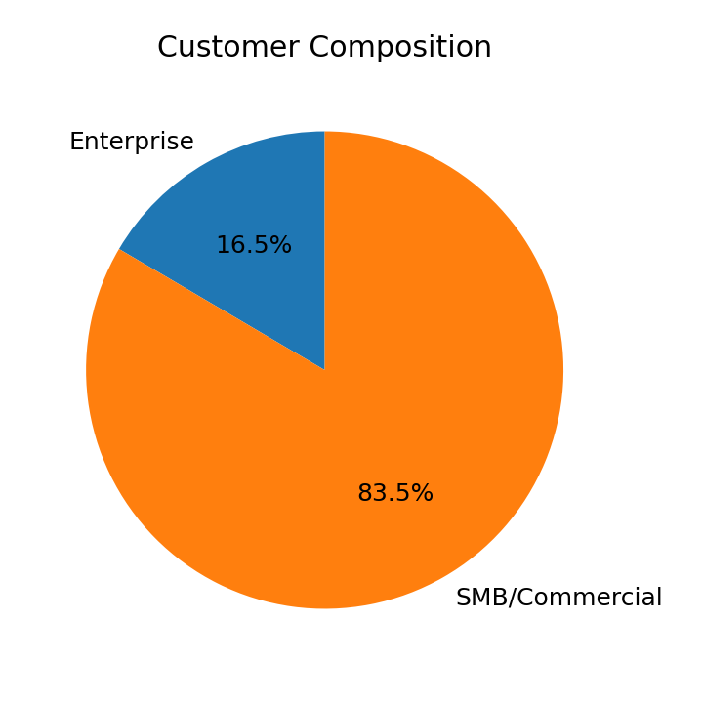

5. Operations and Capabilities
Organizational Structure: Product (420), Engineering (310), Security & Compliance (90), Sales (160), Marketing (70), Customer Success (80), G&A (20). Leadership operates with OKRs, quarterly portfolio reviews, and DevSecOps practices.
Operational KPI | Current
Release Frequency (per month) | 10–12
Mean Time to Restore (MTTR) | 34 mins
Change Failure Rate | 2.1%
Support First Response (mins) | 19
SLA Uptime | 99.92%

Technology Infrastructure: Multi-cloud (Azure, AWS), Kubernetes-based microservices, data platform (Azure Synapse), observability (OpenTelemetry + proprietary Insight), strong cybersecurity posture (SOC 2 Type II, ISO 27001). IP includes orchestration heuristics and policy engines.
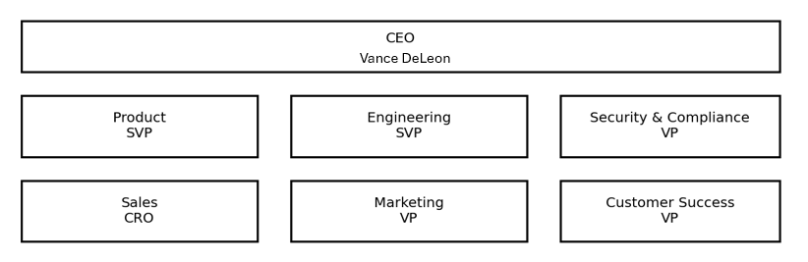

6. Intellectual Property and Product Roadmap
Asset | Type | Status
Adaptive Orchestration Engine | Proprietary Software | Copyrighted
Policy Graph Compiler | Algorithm + Software | Patent Filed (EU/US)
Edge Autonomy Module | Software | Copyrighted
Security Drift Analyzer | Algorithm | Patent Filed (US)

R&D Investments: 2025 spend $36.8mm (11.3% of revenue). Focus areas: AIOps remediation, identity-aware policies, sector packs for healthcare/retail.
Release | Quarter | Highlights
Insight 3.2 | Q1 2026 | Anomaly root-cause ML
Secure 2.5 | Q2 2026 | Policy-as-code templates
Control 4.0 | Q2 2026 | No-code workflow builder
Edge 2.1 | Q3 2026 | Offline device orchestration

7. Strategic Fit and Synergies
Complementary Strengths: Relecloud’s orchestration + security suite aligns with Fabrikam’s digital product portfolio and enterprise go-to-market. Shared target accounts in fintech and retail provide immediate cross-sell velocity.
Synergy Area | Est. Annual Benefit (USD mm) | Timing
Revenue Cross-sell | 22–28 | 12–24 months
Upsell to Enterprise Tier | 8–12 | 6–12 months
Services Consolidation | 6–9 | 6–12 months
Cloud Infra Cost Optimization | 4–6 | 9–18 months
G&A Overlap Reduction | 3–4 | 6–12 months

8. Risks and Challenges
Risk Category | Description | Mitigation
Financial | Revenue concentration (Top 10 = 31%); price pressure in enterprise negotiations. | Diversify sectors, multi-year contracts with price floors.
Operational | Scale-up hiring in engineering; dependency on senior architects; incident response capacity. | Succession planning, SRE expansion, on-call rotation automation.
Market | Competition from hyperscaler-native tooling; feature parity arms race. | Differentiation via integrated platform, outcome SLAs.
Regulatory/Legal | Data sovereignty rules (EU/UK); evolving AI regulation; IP litigation exposure. | Regional data controls, legal reserves, patent strategy.

9. Future Outlook
Year | Projected Revenue (USD mm) | Projected EBITDA (USD mm)
2026.0 | 392.0 | 94.0
2027.0 | 476.0 | 116.0
2028.0 | 565.0 | 140.0

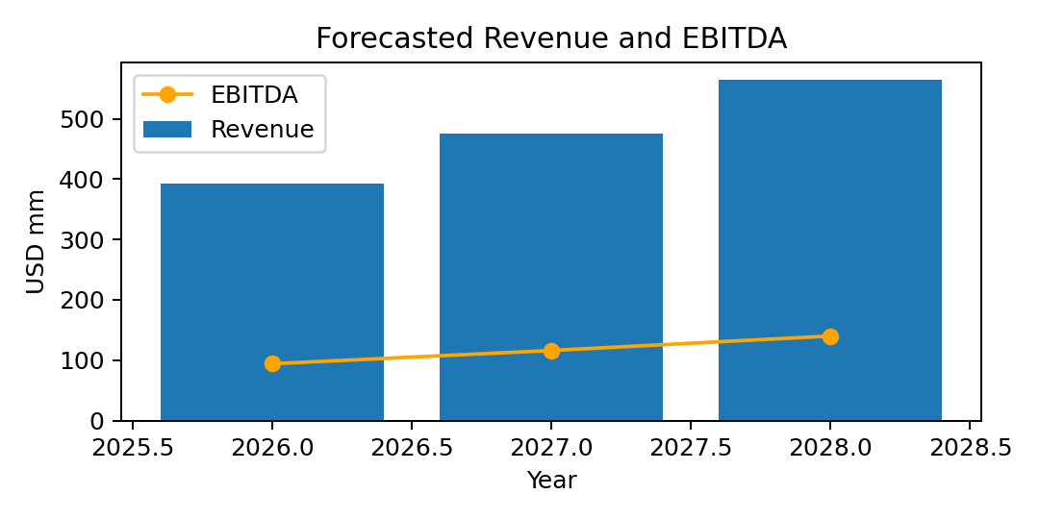

10. Summary Assessment
Valuation Rationale: Given growth, margins, and synergy potential, an EV/ARR multiple of 6.8–7.5x appears reasonable (implied EV range $1.7–$1.9bn on 2025 ARR $255mm).
Deal Considerations: Full acquisition vs. majority stake with earn-out tied to enterprise-tier ARR growth. Integration phased over 12–18 months, with brand retention in EMEA for continuity.
Recommendation: Relecloud is a strong strategic fit for Fabrikam’s expansion into secure multi-cloud operations. Proceed to detailed due diligence focusing on enterprise churn drivers, roadmap execution, and EU data localization commitments.

